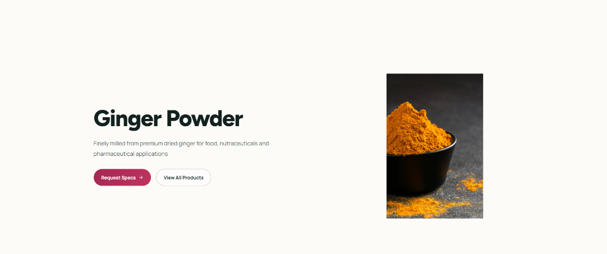
Please change this picture. This is very clearly turmeric powder.

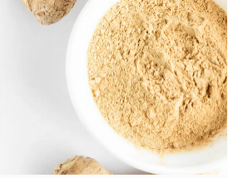
Use this for ginger powder

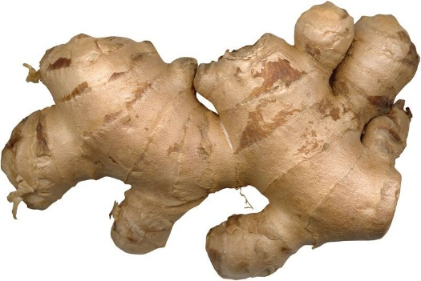

Change from freshly harvested rhizome - Fresh ginger Rhizomes and use this photo

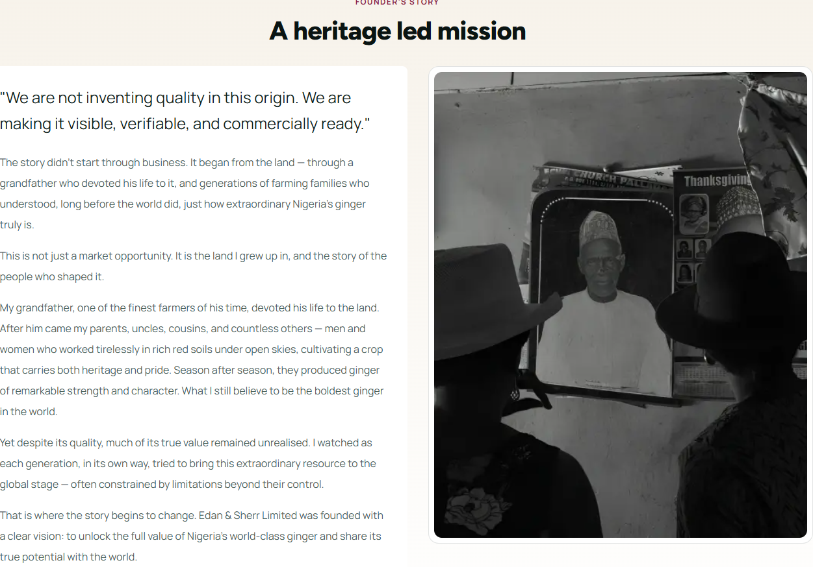
Please remove the current header statement in red and replace that with one in blue.
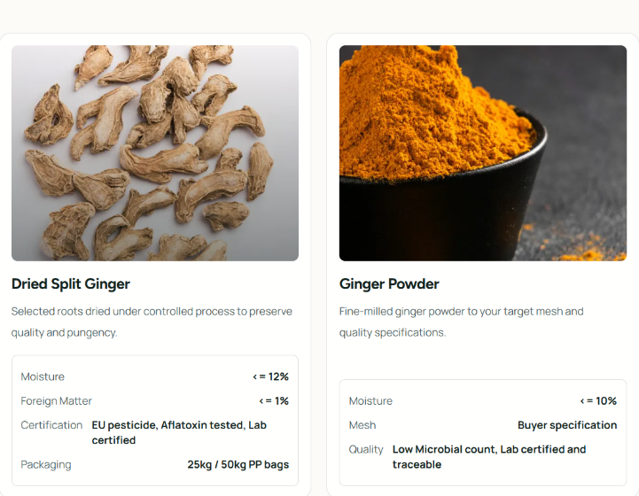
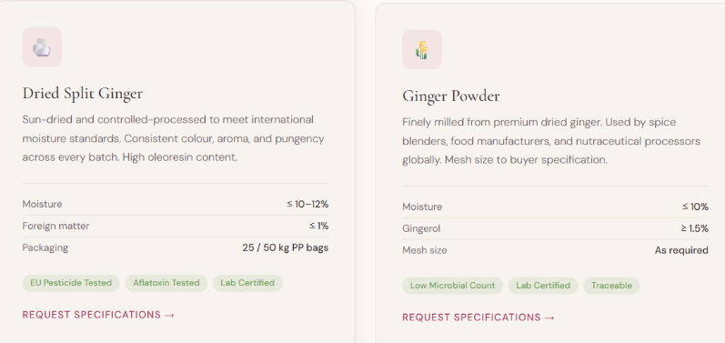

Please put EU pesticide tested etc in a small box like this.

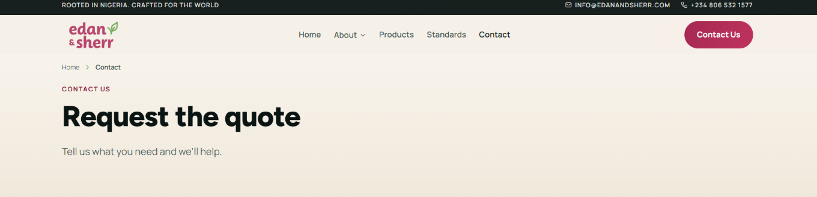
Please remove contact us and Tell us what you need and we will help.

Change Request quote to Send an Enquiry

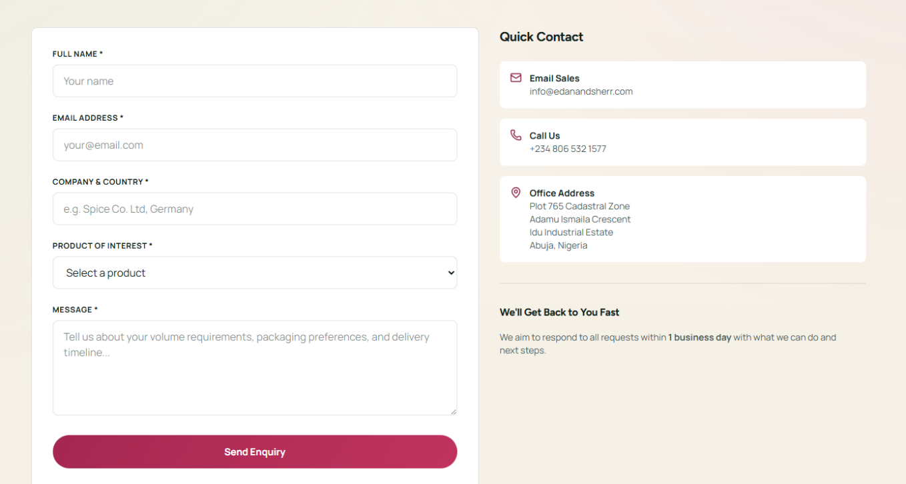
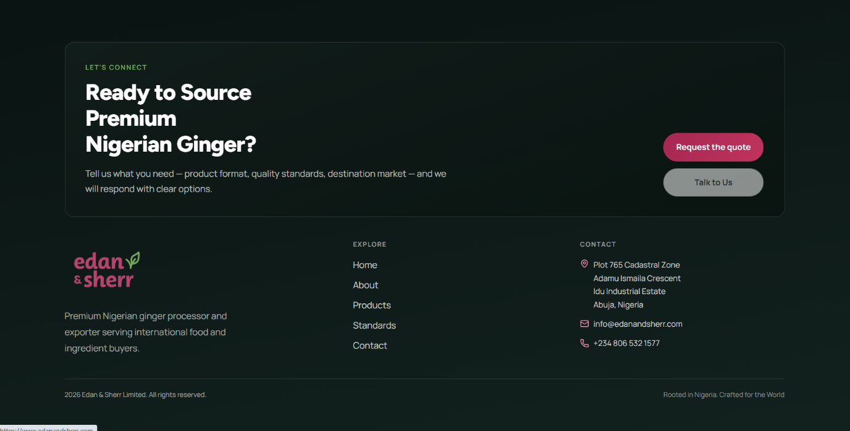
Please remove the quick contact

Please remove the talk to us button.

Change the Request quote to Send an Enquiry and let it lead back to the contact us page.

